Assignment B.6 - Milligan Chapter 6
Student Name: | < Replace this text with your name >

Week 4 - Milligan Chapter 6

Welcome to your hands-on activity! This assignment invites you to work with Tableau using a mix of generated and real-world data. You will:
- Download the attached spreadsheet and upload those data sets into Tableau. If you need help loading your data source, refer to Assignment A.2 for help.
- Go through this document and use Tableau to answer all the questions listed below. Where applicable, paste screenshots into the template below.
- When you are ready, complete the online quiz which verifies your homework. You are welcome to refer to this document when you complete the quiz.
- You are welcome to use the quiz results to update your homework file.
- When you have completed the online quiz, submit the Word document.
- Remember, you can always ask your instructor for help if needed.
- If you need to adjust the size of your visualizations to match the options in the questions, use the “Format”->”Cell size” options. For example, “Ctrl+Shift+B” on a Windows computer will make the visualization bigger and “Ctrl+Up” will make it taller.

The spreadsheet attached to this assignment contains one dataset:

- B.6 Video game sales

Question 1: Quick Calculation Running Total

You work in the sales department for a video game company, and you’ve been asked for the total amount of sales over time compared to the total per year. Load the B.6 Video games sales data into your Tableau. To create a running total, we will drag the “Year” dimension into columns and “Global Sales” into rows. You should get the following line graph:

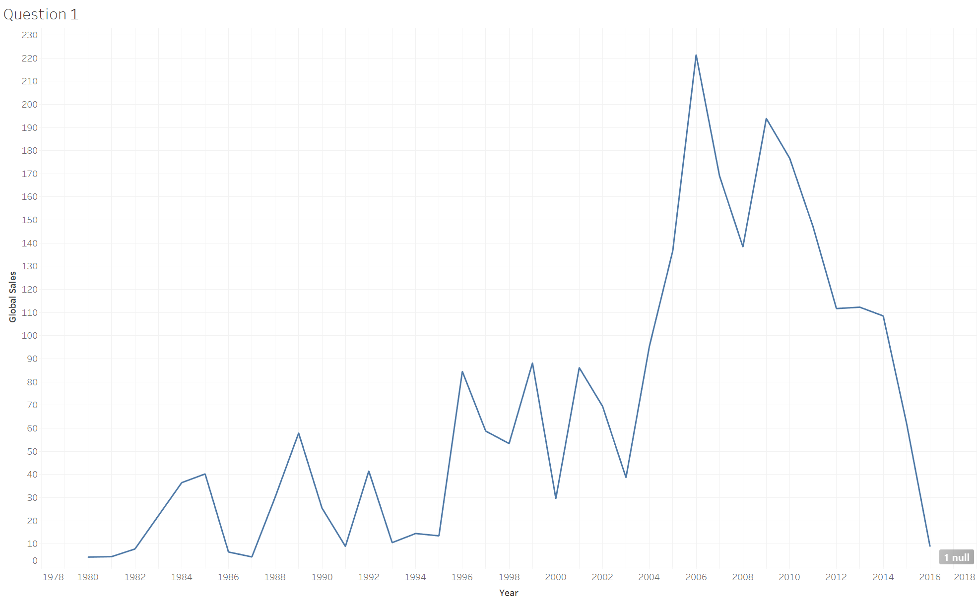
This is helpful if we want to know the total amount of video game sales in each year, but you’ve been asked for the total over time. To do this, a table calculation using the quick calculation: running total is most appropriate. Drag “Global Sales” over and put it next to the Sum Global Sales you did in the last step. Now you should see two identical graphs.

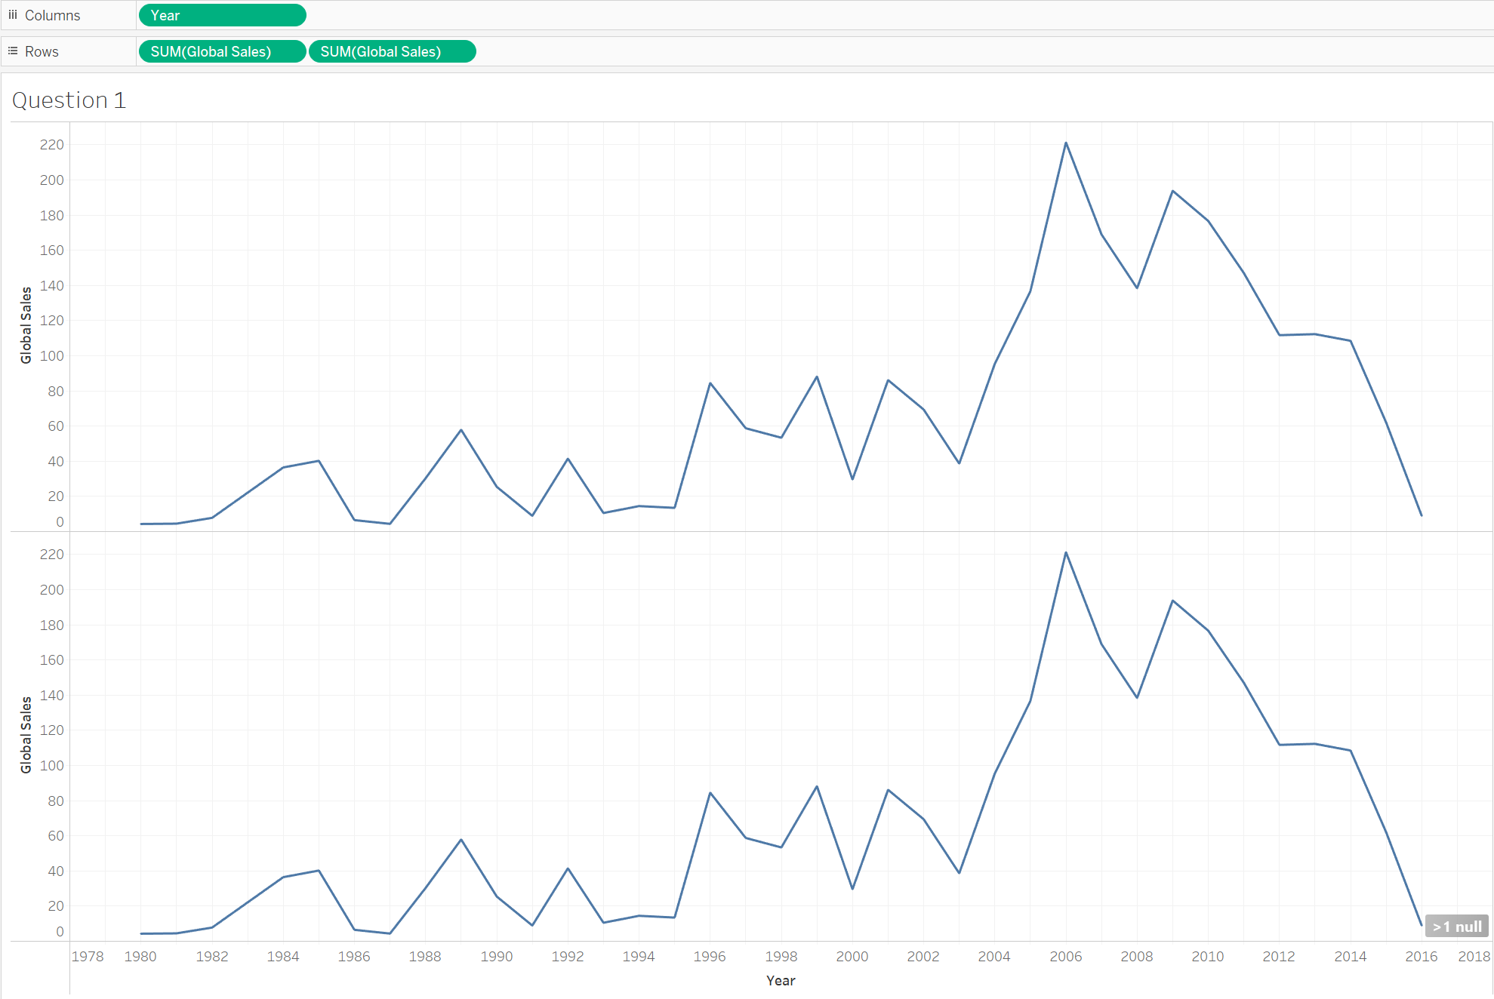
Right-click on the second SUM(Global Sales) that you just added and click the “Quick Table Calculation”. This will provide you options, click on “running total”.

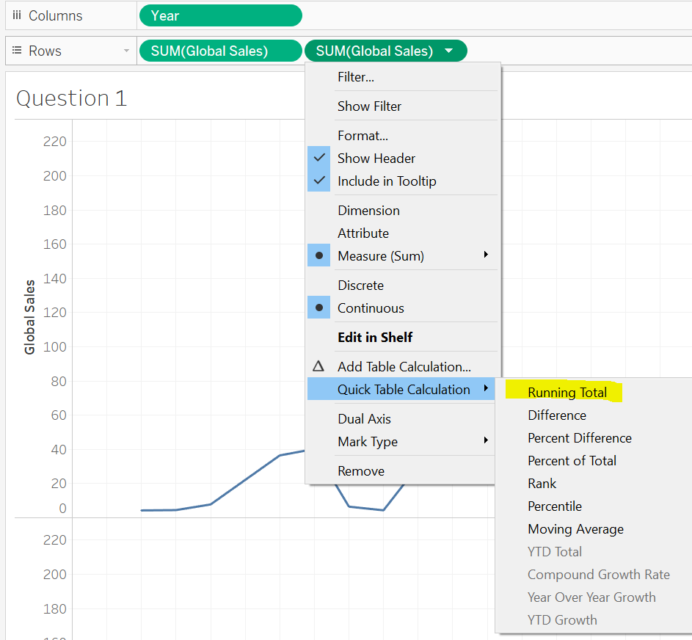

Now, you should have two different line graphs, one showing a total each year and another showing the running total over time.
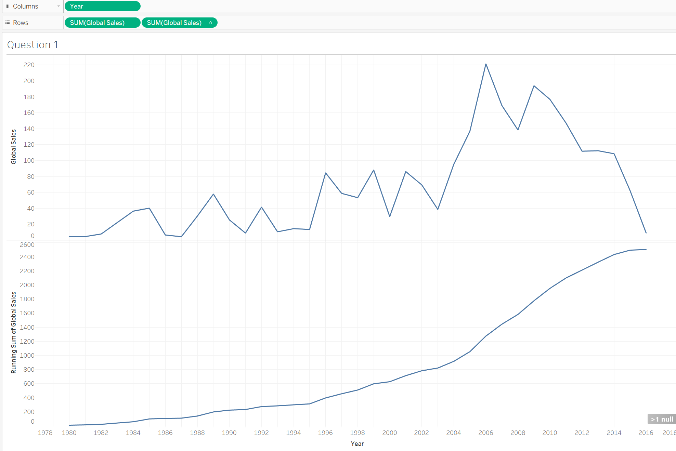

Now, you are asked to create this same visualization, but using only North American sales (NA Sales). Which of the following is the correct graph you were asked to make?

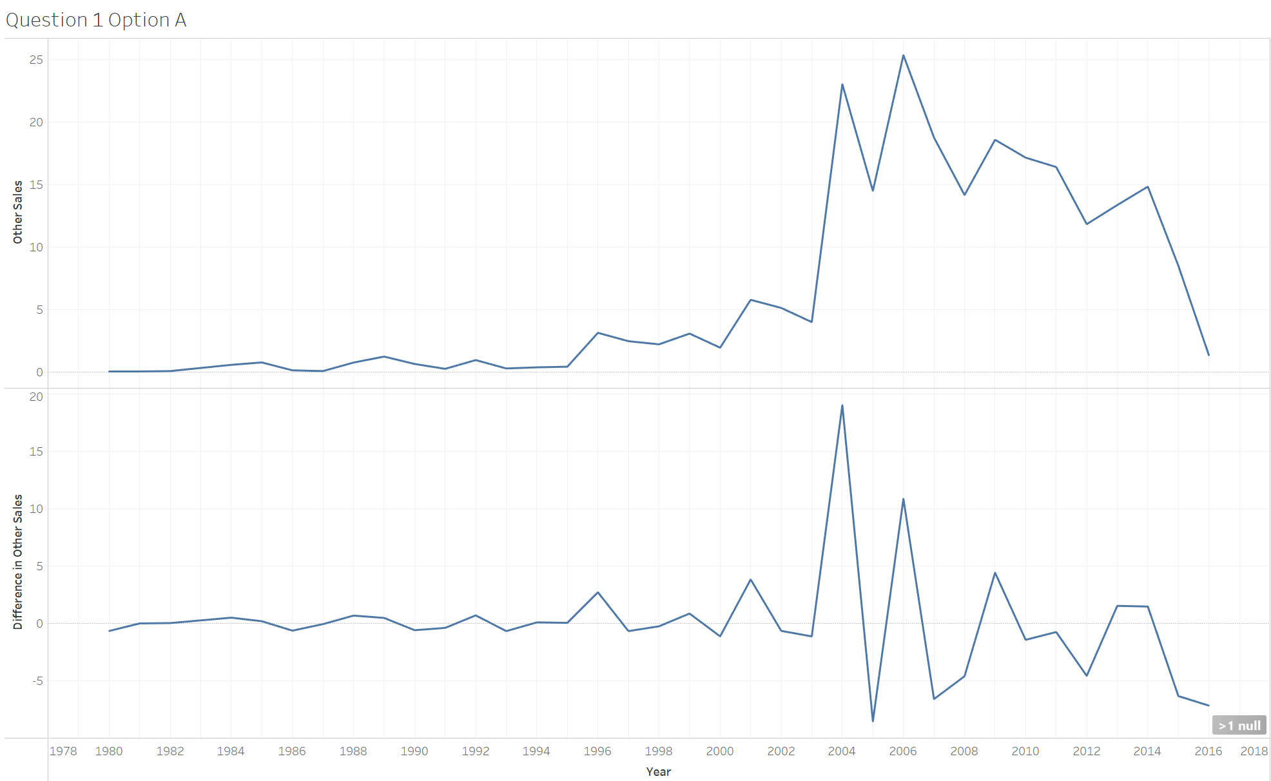 | 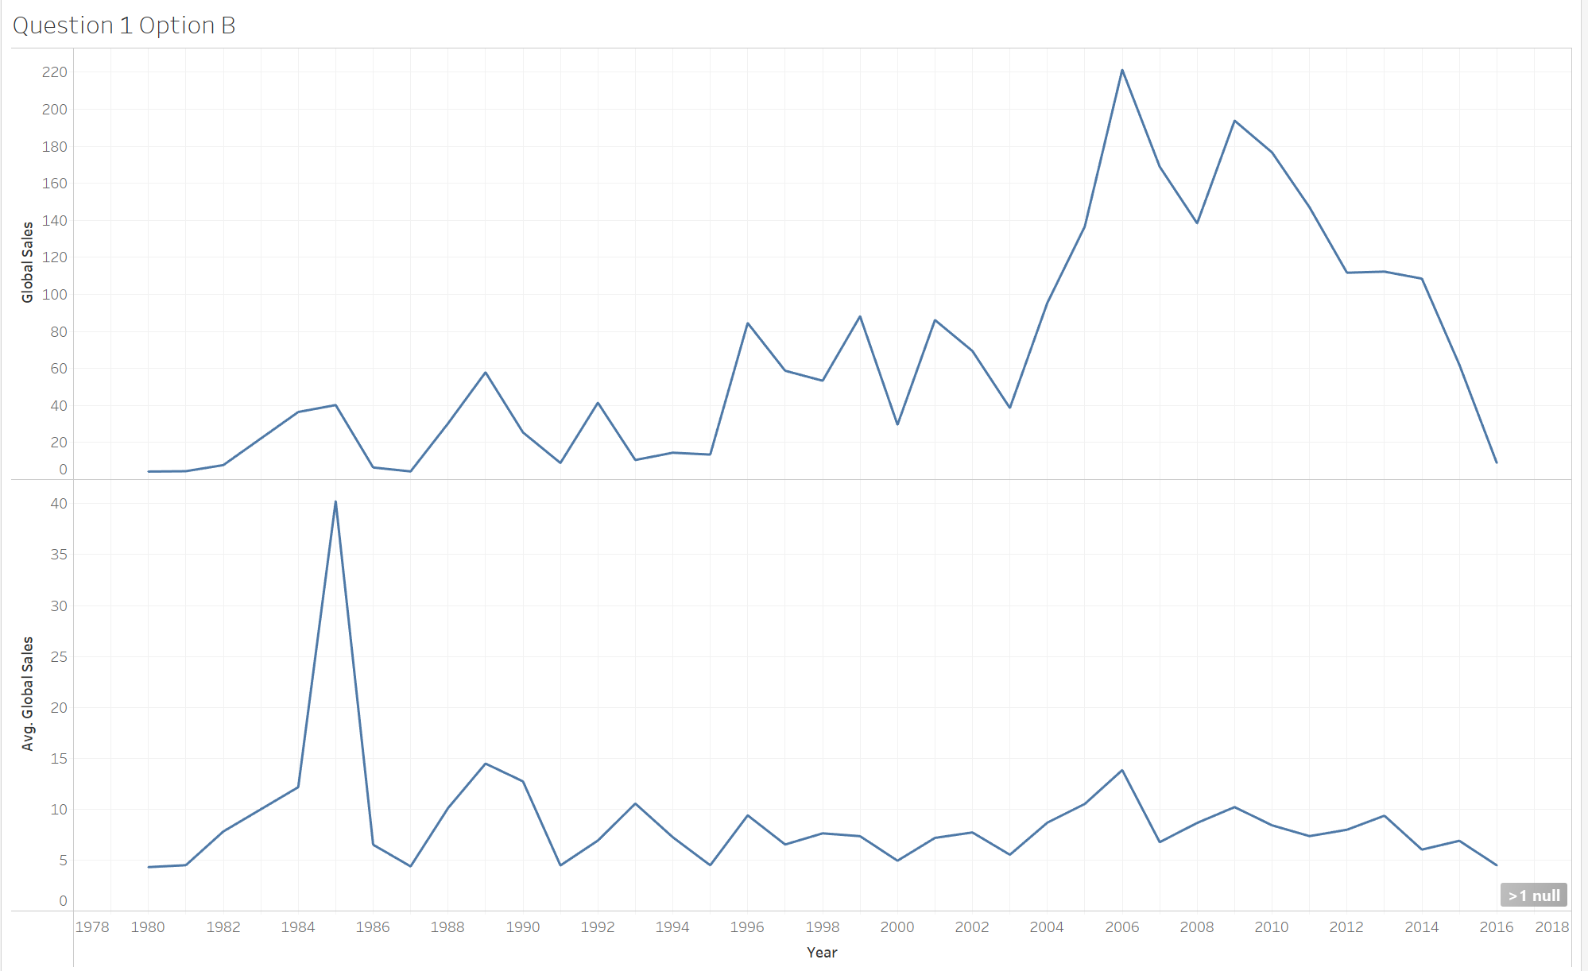
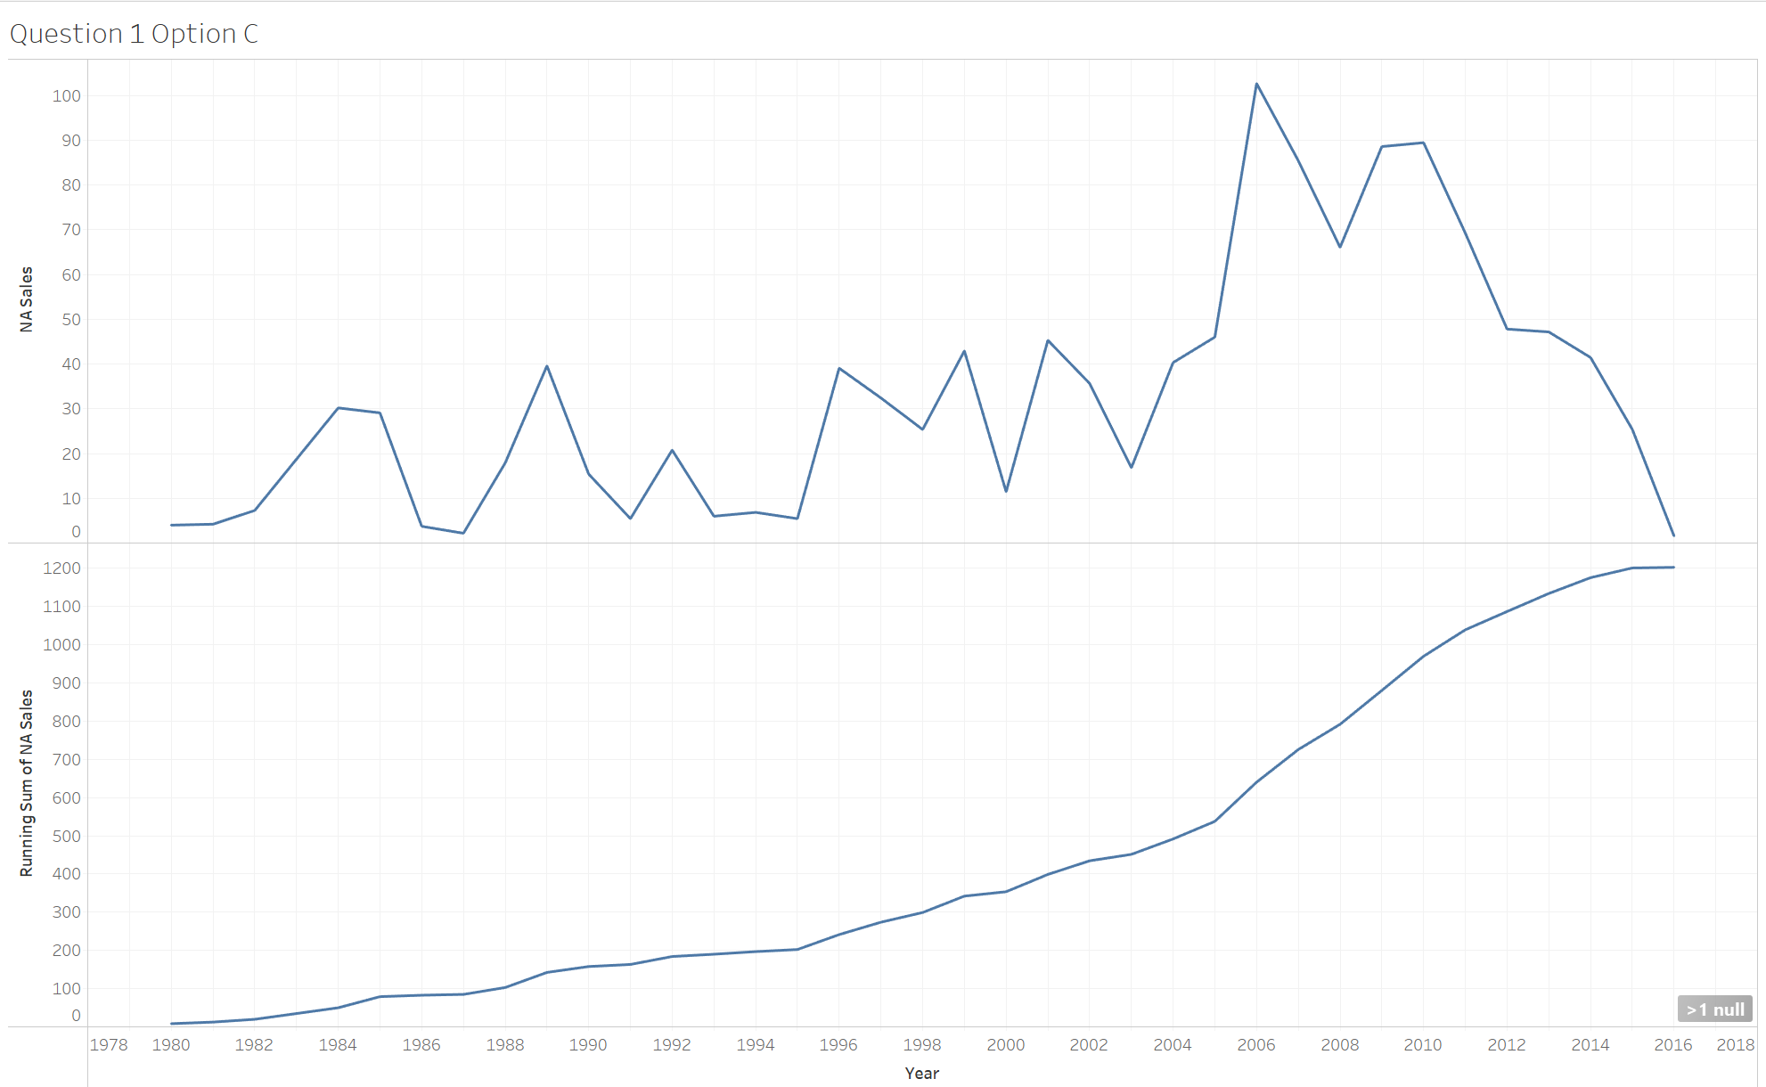 | 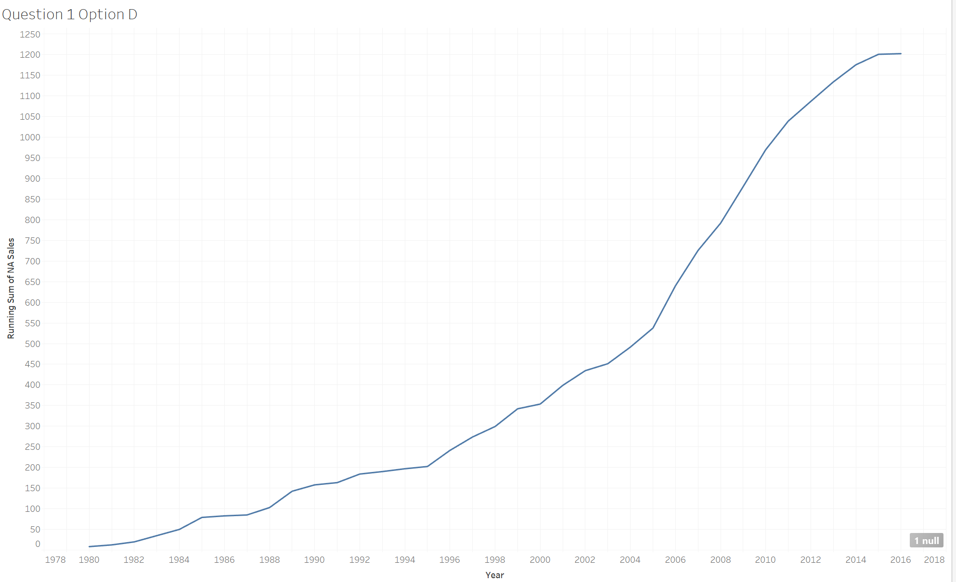

Question 1 Answer: | Option C

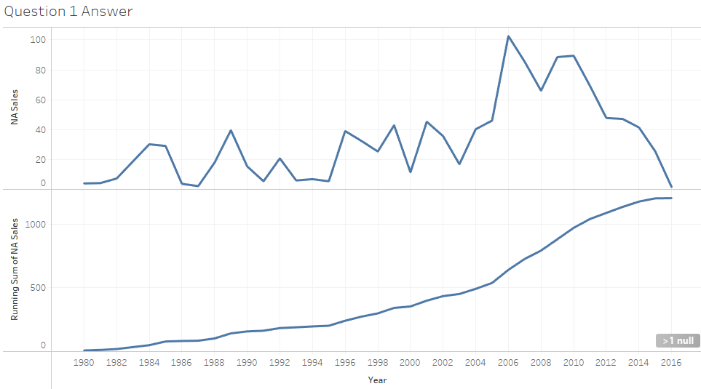

Question 2: Rank

Your team at the Video Sales company is happy with your running sales in North America, but now they want to know where each year ranks for sales. To do this, you can create two calculated fields that you’ll also use as table calculations. First, we will do this for Global Sales and then you will do it for North America sales. We will be creating two new calculated fields for Global Sales: running total and rank.
Under the analysis menu, click on “create calculated field” as shown in the image below.
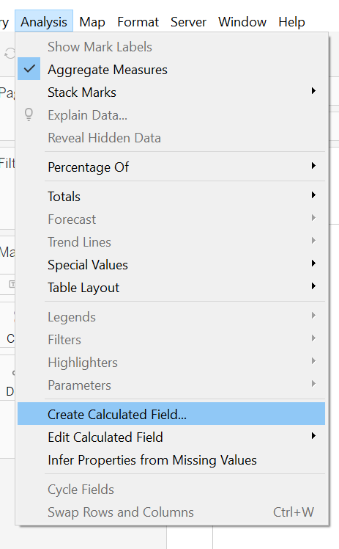

Change the name to “Running Sum of Sales” with the syntax: RUNNING_SUM(SUM([Global Sales]))
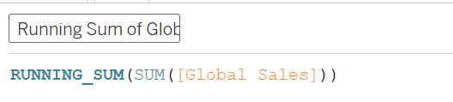

Then create a second one called “Rank of Global Sales” with the syntax: Rank(SUM([Global Sales]))
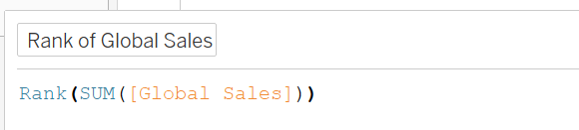

Next, we are going to use the “Year” dimension, but Tableau doesn’t know it is a date, so change the Data Type of Year to Date. This is so that Tableau will provide us with date-specific functions that we might want to use.
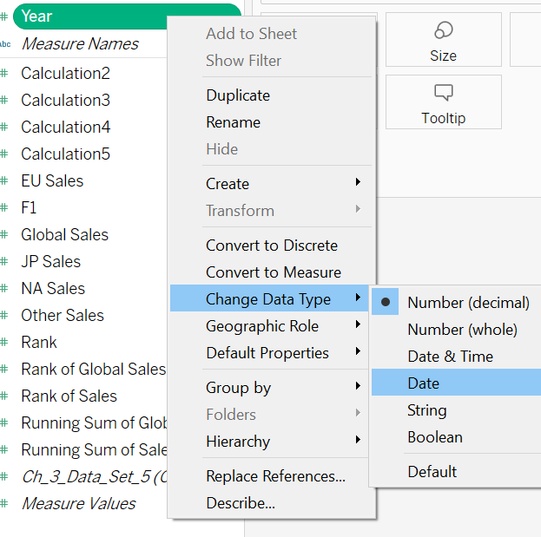

Next, we are going to build a text table. To do this, you will click on the Year + Ctrl + Global Sales + Ctrl + Rank of Global Sales + Ctrl + Running Sum of Global Sales (Replace Ctrl with CMD if you’re on Mac). This should make all four highlighted on your data tab.
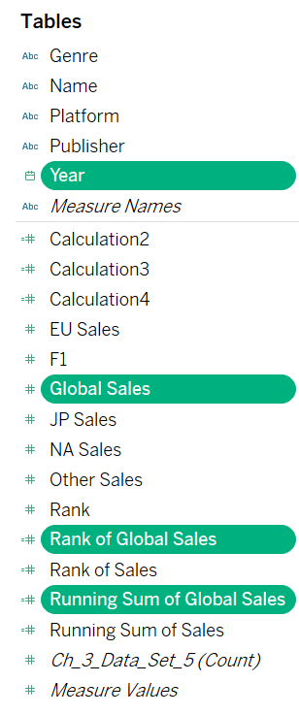
Now, click on Show Me and choose “Text table” (top left-hand box). 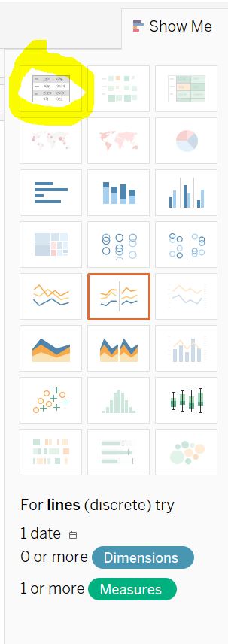This should create a table that looks like this:
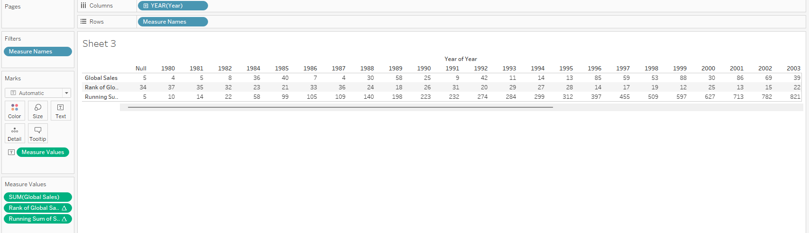

We want to switch the order of columns and rows so click on the swap rows and columns button.
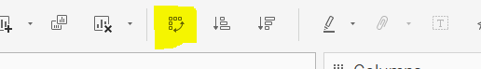

Now, your text table should look like this:

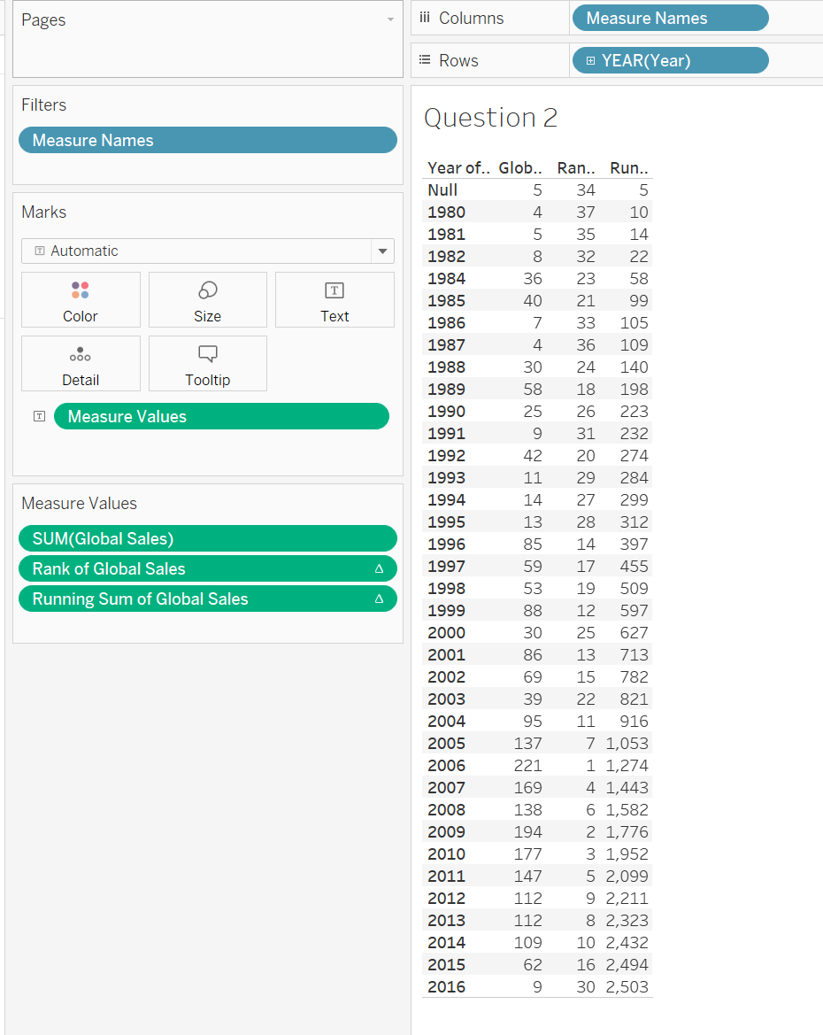

We can widen the columns by clicking the ctrl button (CMD button on Mac) and the right arrow a few times.

Now, the table is sorted by year, let’s change the sort to be ascending by Rank of Global Sales. Click on that column and click on the sort ascending button on the tool bar.
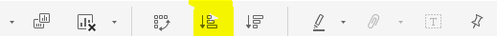
Now, your table should be sorted by rank with the highest on top:

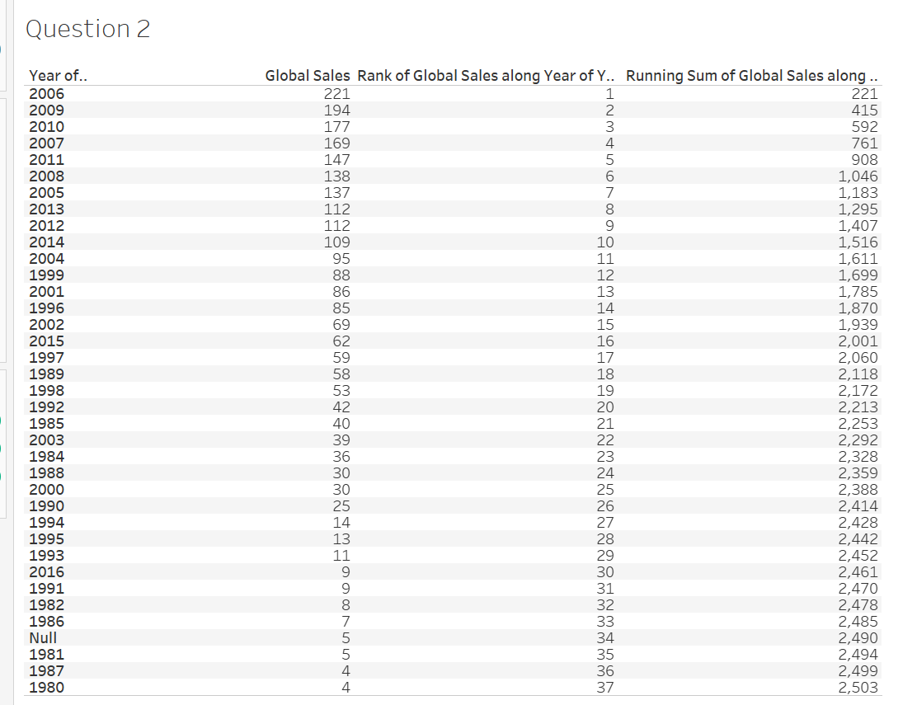
This is helpful because we can see that the year with the highest sales was 2006 and the year with the lowest was 1980. We can also see that the running sum of global sales is totaling down the far-right column so we can see it over time.

Now, you will perform this same operation, but for North American Sales. What year had the lowest sales?

____ enter the year

Question 2 Answer: | 2016

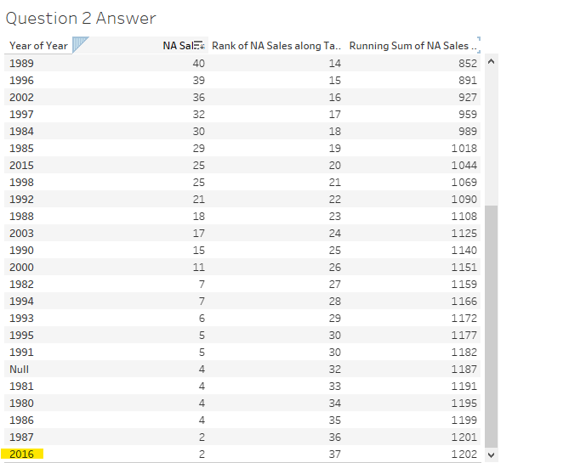

Question 3: Relative to table

Let’s use the table you made in question 2, North American (NA Sales) by year. Now we want to dive into specific genres or types of video games. First, we are asked to examine the Action and Fighting genres. So we drag “Genre” from the dimension table onto the rows to the left of “YEAR(year)”. Then we drag “Genre” into the filters area and select ONLY Action and Fighting.

Now we should have a table that looks like either of these tables (one includes nulls, the other doesn’t)
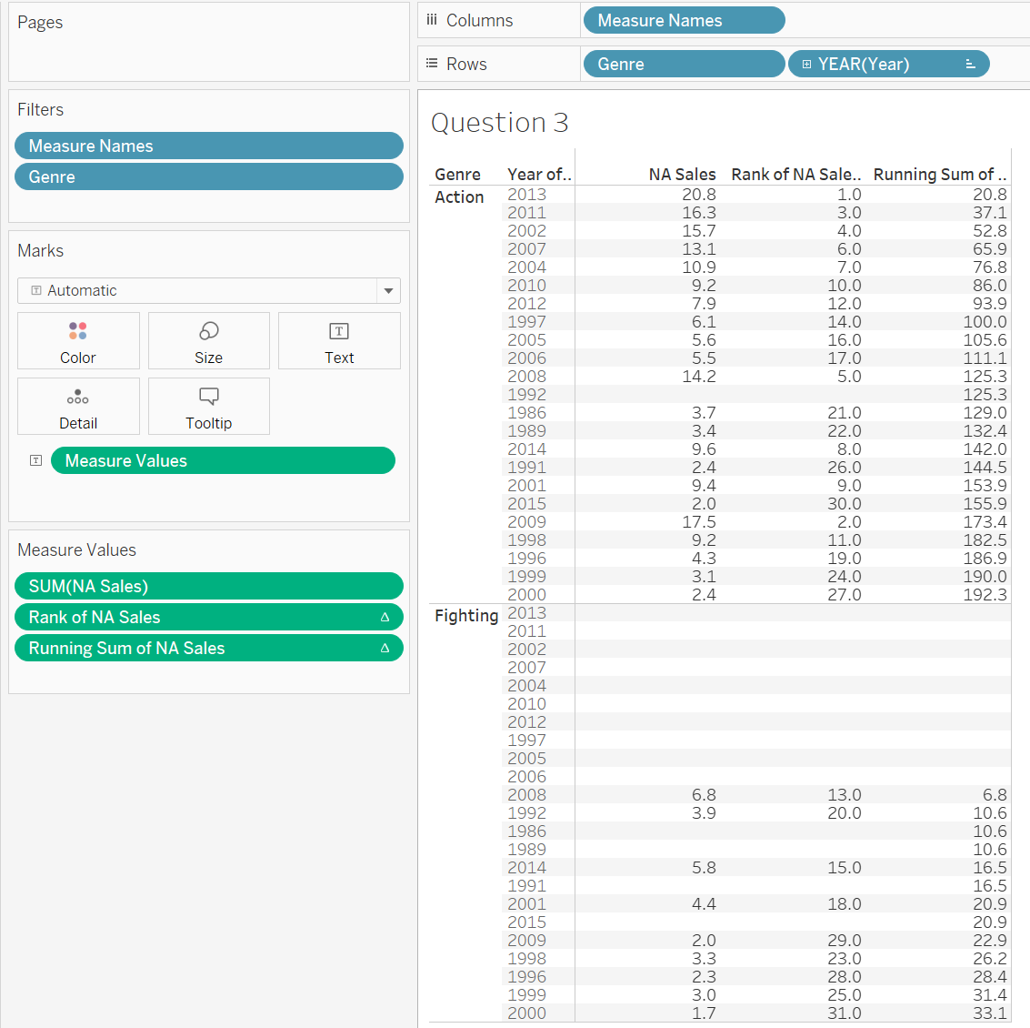
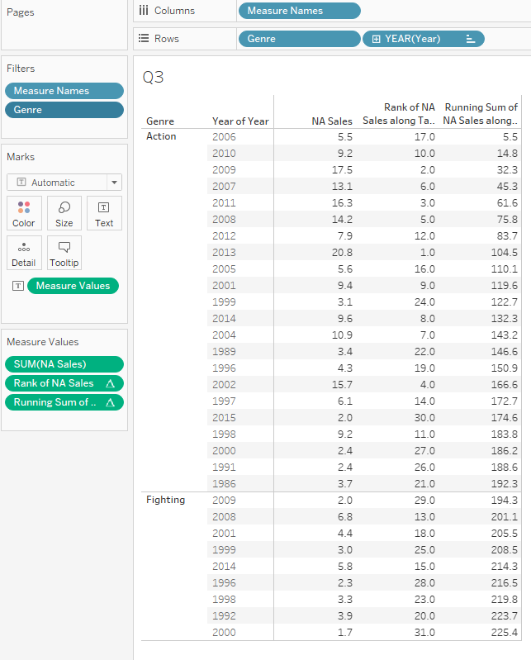
You are asked to find the rank of the years of North American Sales for Action and then the top year for Fighting. In other words, what year was the top for each genre? To do this, we will change the calculation relative to the table. The calculation was previously computing using the table (down) because we only had one dimension (year). But now we have two dimensions- year AND genre which creates a pane for each genre. So, we are going to change the table calculation to use the Pane (down). To do this, right-click on the “Rank of NA Sales” and click on Compute Using - Pane (down).
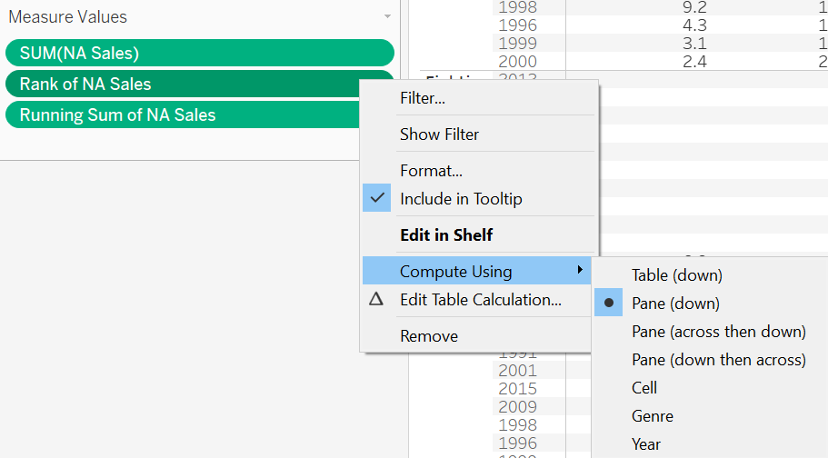
You should see that the table changed the calculation. Now you should be able to pick out the top year of sales for Action (2013) and for Fighting (2008).

Now, you have been asked to do the same thing for Role-Playing and Sports.

What are the top years for each?

Option A: Role-playing – 1999/Sports - 2007
Option B: Role-playing – 2010/Sports - 2006
Option C: Role-playing – 2008/Sports - 2006
Option D: Role-playing – 2006/Sports - 2009

Question 3 Answer: | Option B: Role-playing – 2010/Sports - 2006

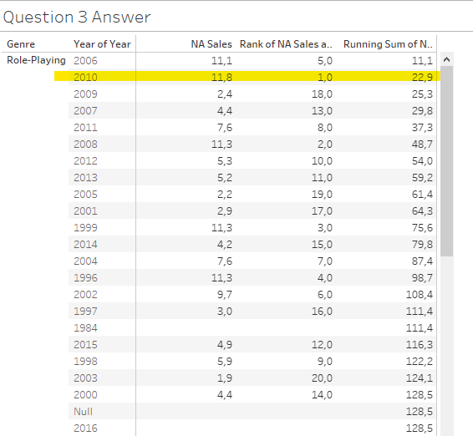

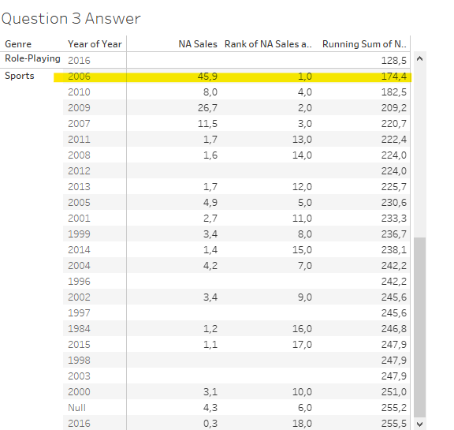

Question 4: Scope and direction

You have been asked to analyze video game sales for the last five years (2012-2016). You would like to see the running totals of global sales across the platforms by genre and publisher. To do this, you will highlight Genre, Platform, Publisher, Global Sales, and Running Sum of Global Sales (remember to hold down the ctrl button). Click on “Show me” and choose “Text Table”.

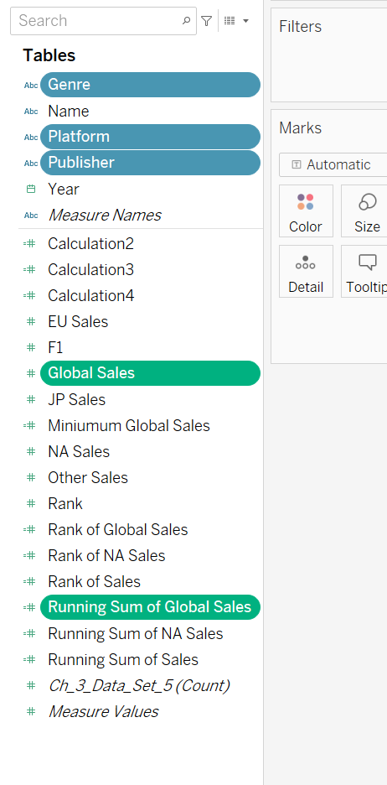
Make sure “Platform” is in the columns and “Publisher” is in the rows.
You will get a large text table that looks like the following:
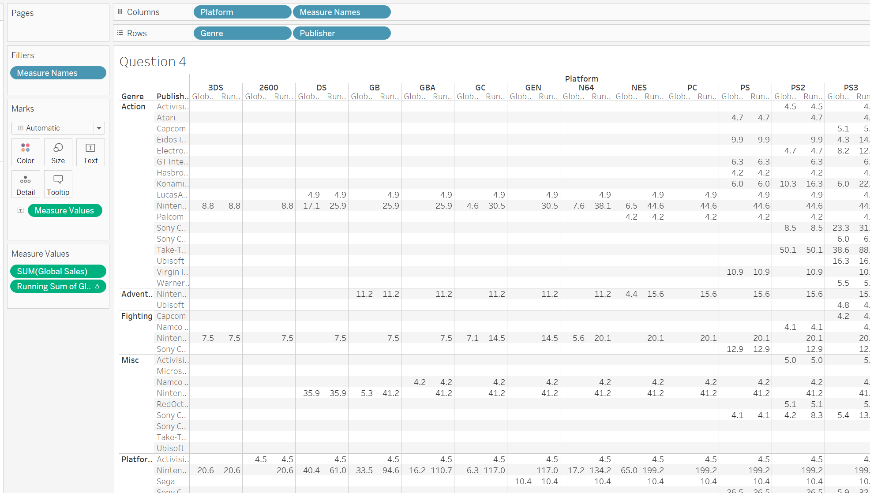
But we need to set a filter, so drag “year” over into the filters area and select 2012 through 2016.
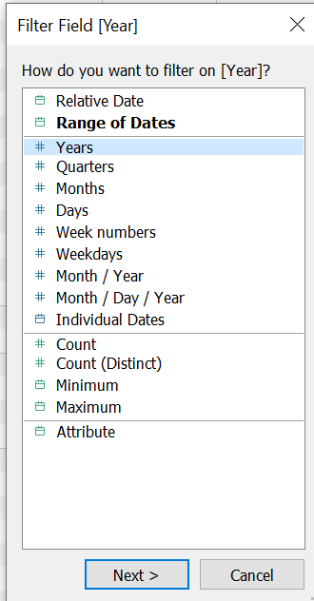

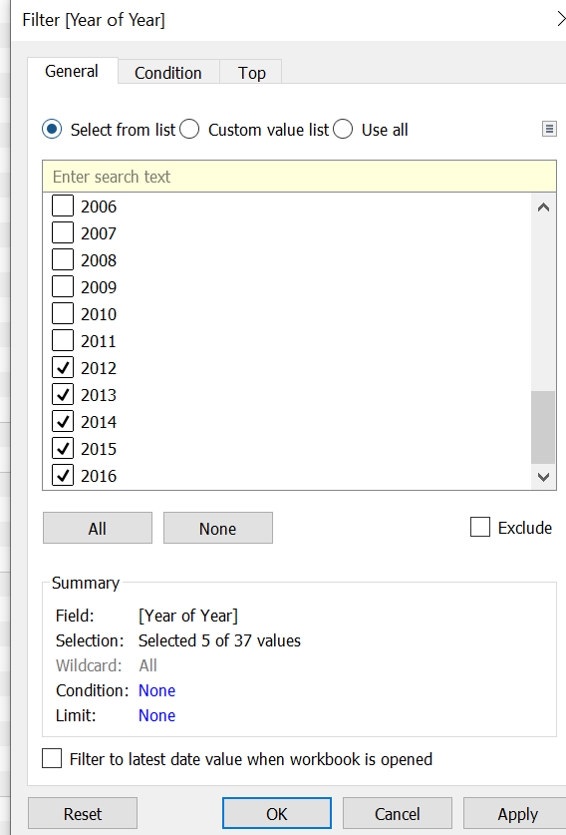
Now, you will have a table like this:
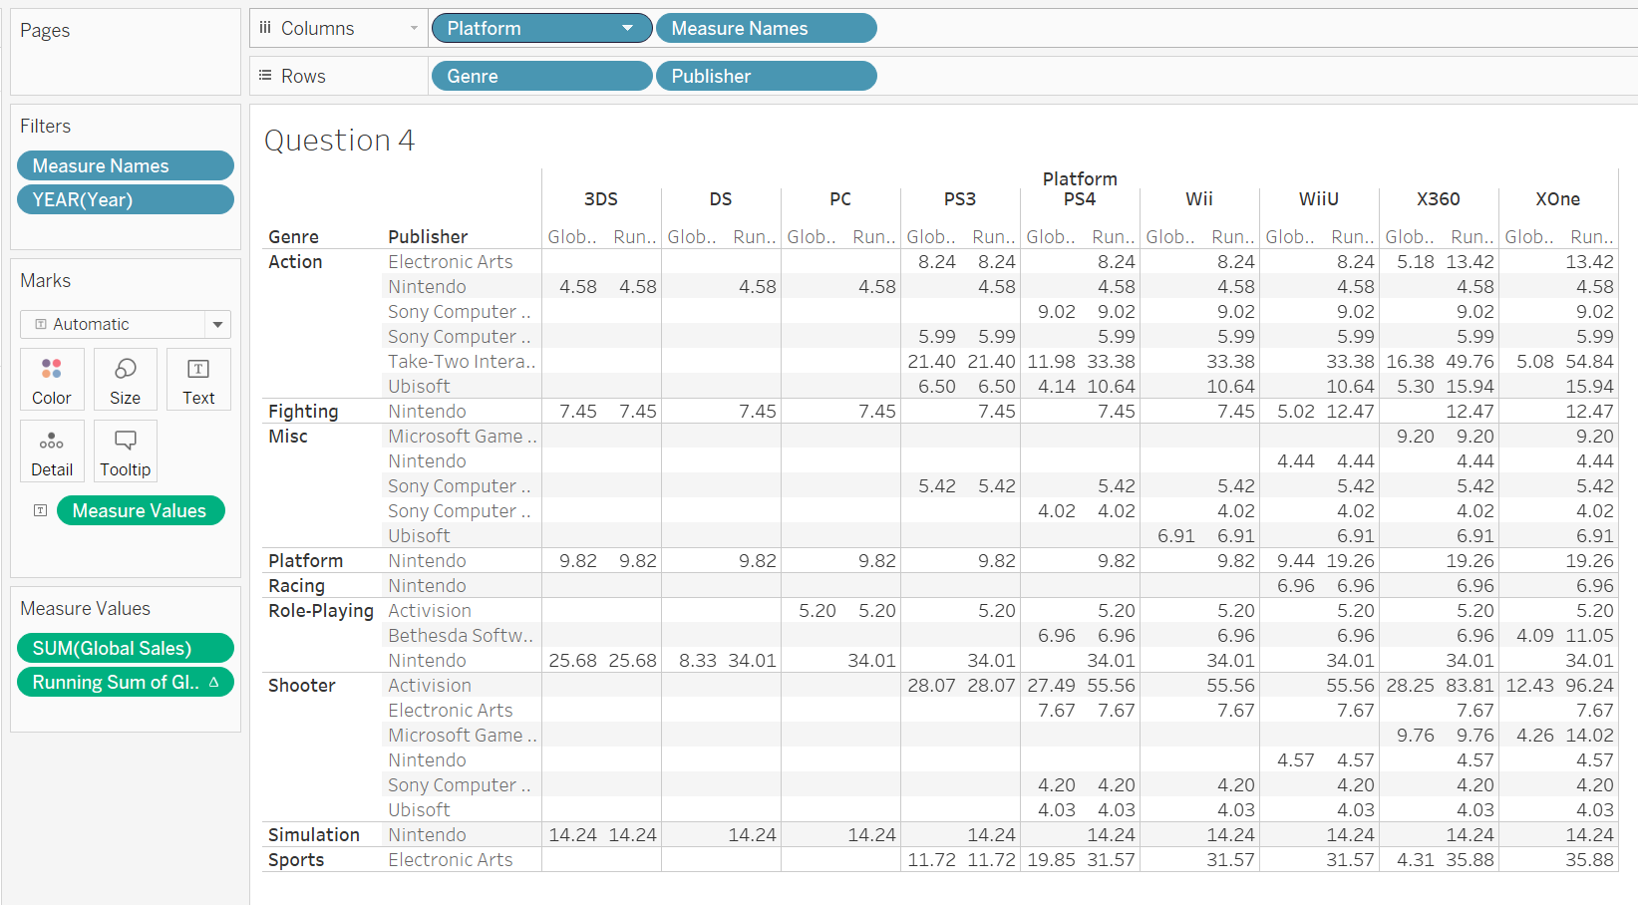

Now, we are going to experiment with the different scope and direction options for the table calculation: running sum of global sales.

Right click on the table calculation and click on compute using- Table(down)
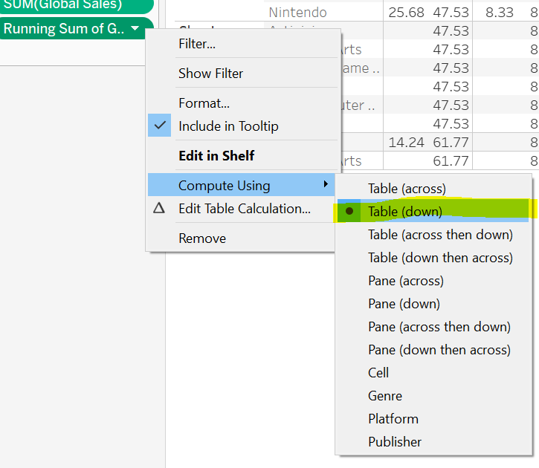
You should see your table calculations changed to this
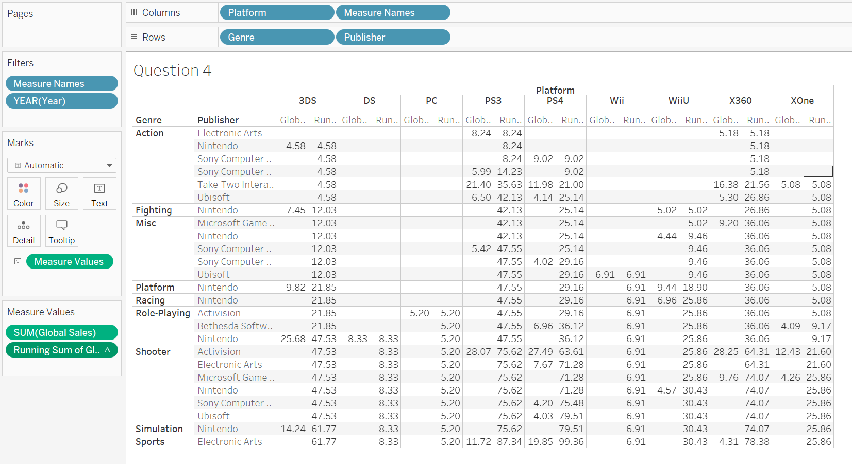

Now, you can see that on the PS3 Platform, the total amount of global sales for all publishers and genres was 87.34.

Next, change the table calculation to total Table (across and down).
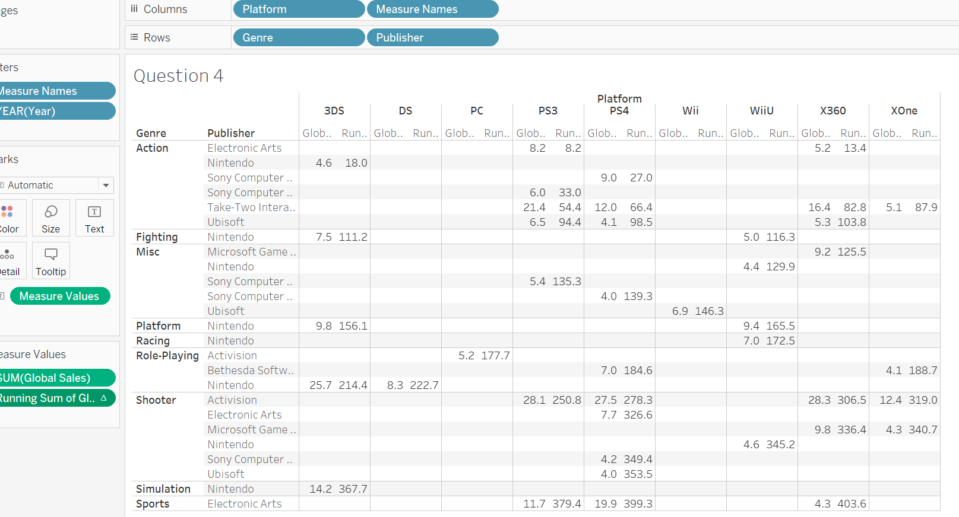
Your table looks very different, now you can see that the running global sales starts at the top in Action with Electronic Arts on the PS3 (8.2), then it adds the next Electronic Arts in Action (5.2) to get a total of 13.4. Next, it gets the sales from Nintendo in Action (4.6) and adds it to the total to get 18. This iterates until the final total sales which is 403.6.

Question: if you change the calculation to Pane (across and down), what is the total amount of running Global Sales for PS4 Shooter games?

Question 4 Answer: | 43.39

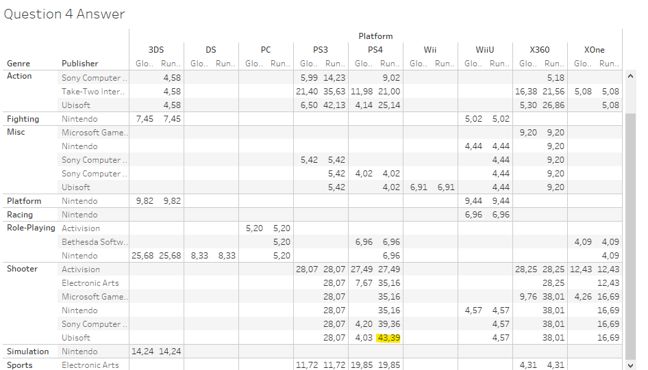

Question 5: Running Functions

The video game company would like to know the minimum sales that each publisher had within a genre. In other words, which publisher performed the lowest in a genre?

Create a new calculated field called Minimum Global Sales with the syntax: RUNNING_MIN(SUM([Global Sales]))

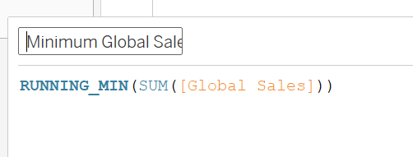
Select Genre, Publisher, Global Sales, Minimum Global Sales, and Running Sum of Global Sales (hold the ctrl button down). Click on the Show Me menu and click on the text table icon.

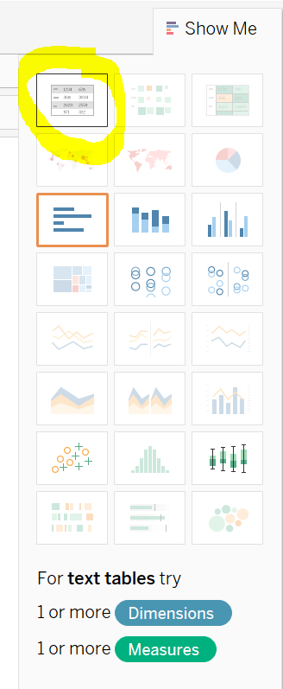
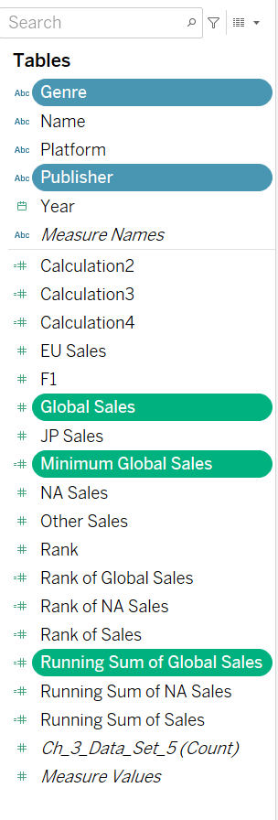

You should have a table that looks like this:

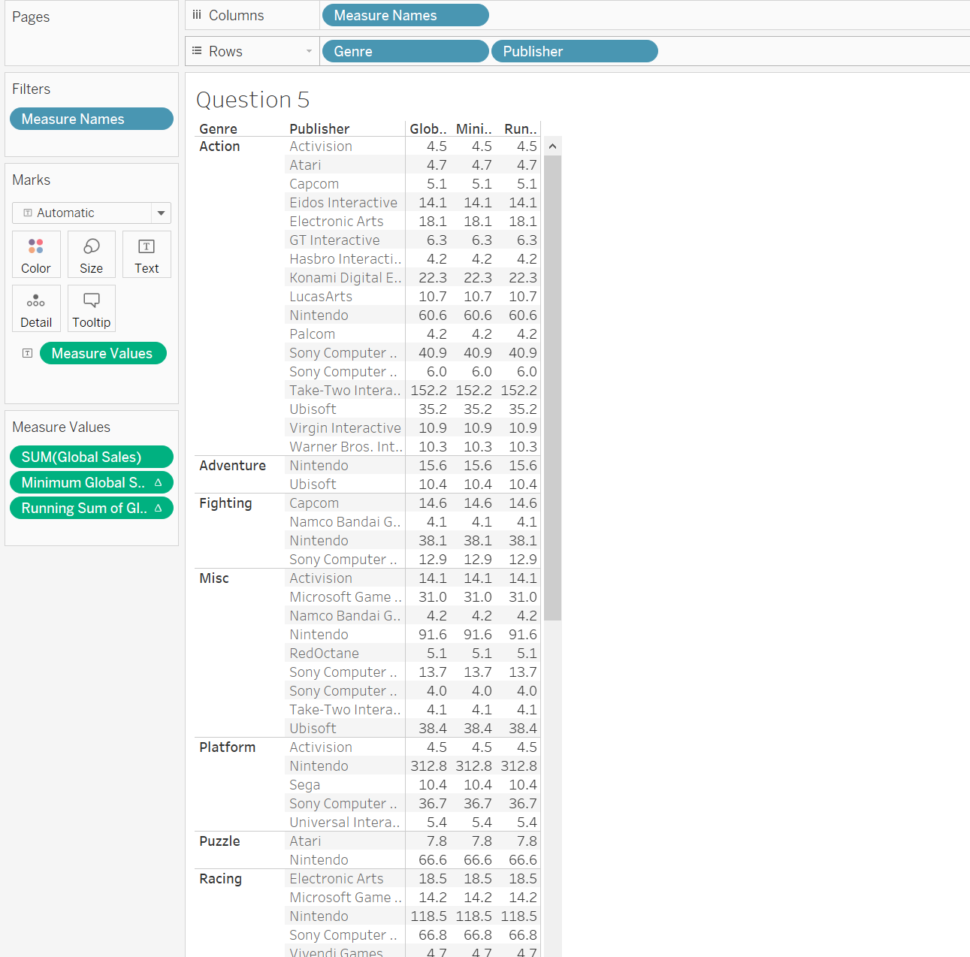

Click on ctrl (CMD on Mac) and your right arrow key to make each column wider.
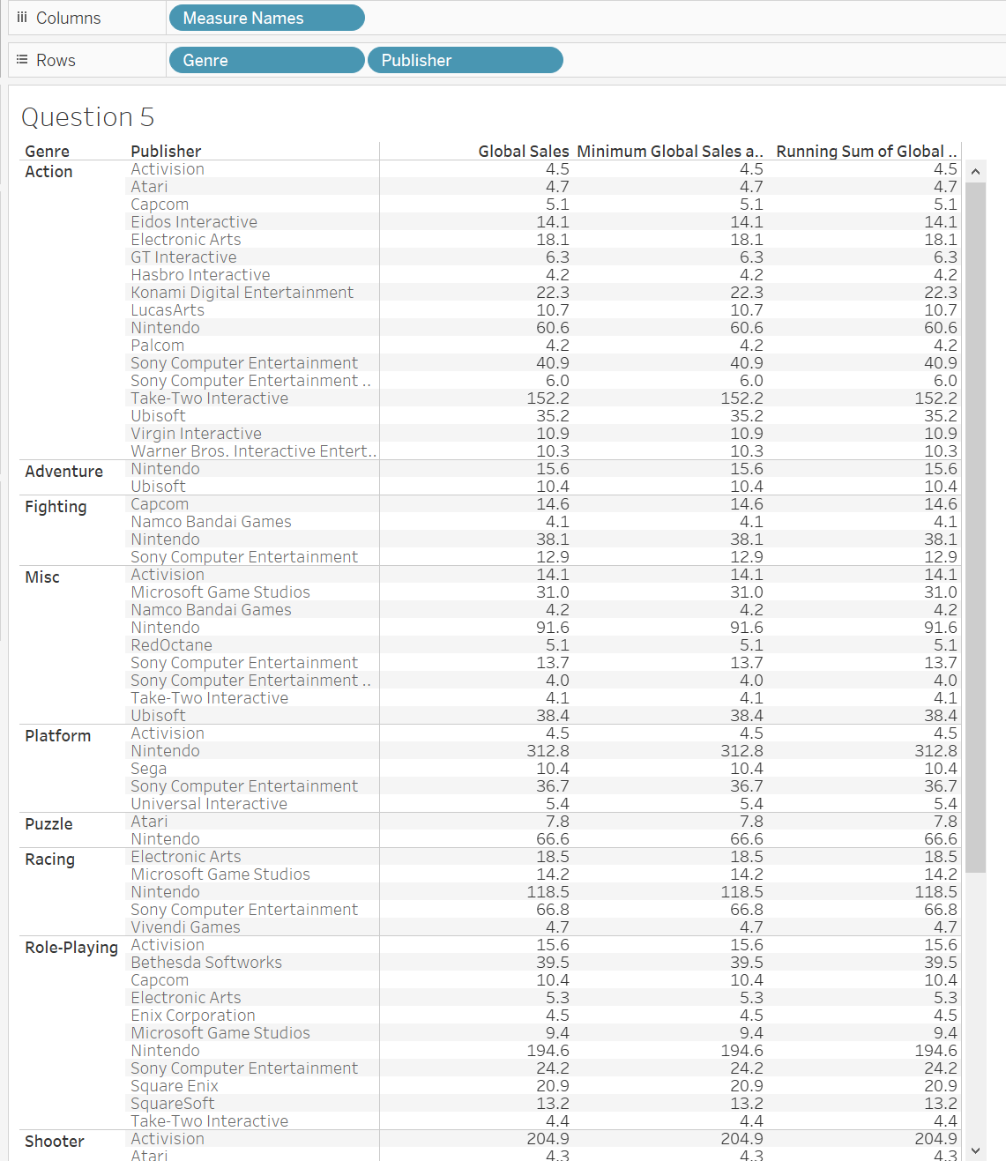
To answer the following questions, you will need to change the way you are calculating the minimum global sales.

Match the answer with the question:

What was the lowest global sales for all genres?
What was the lowest global sales for only the Role-Playing genre?
What was the lowest global sales for only the Sports genre?

Possible answers: 4.4; 6.2; 4.0

Question 5 Answer:

What was the lowest global sales for all genres? Answer = 4.0
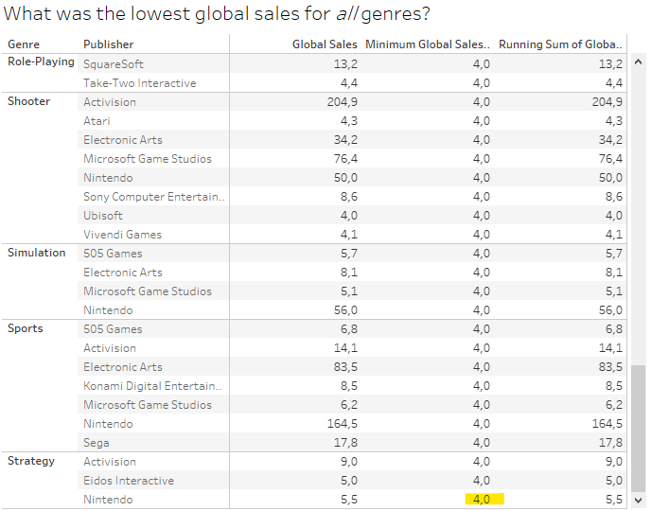

What was the lowest global sales for only the Role-Playing genre? Answer = 4.4

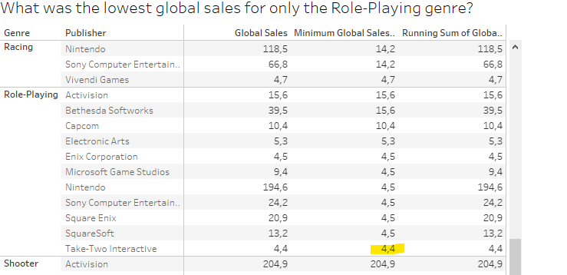

What was the lowest global sales for only the Sports genre? Answer = 6.2

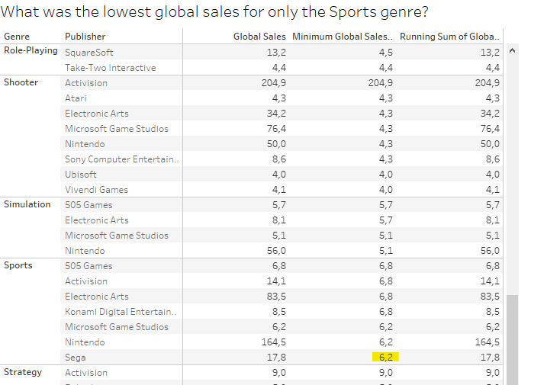

Question 6: Moving average

Someone in your company asked about the average global sales for the video game industry by the different video game platforms.

We will create a bar graph with Sum(Global Sales) in the columns and Platform in the rows.

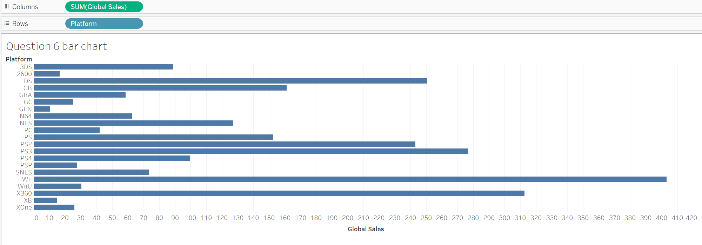

Now, right-click on the SUM(Global Sales) and Quick Table Calculation->Moving Average

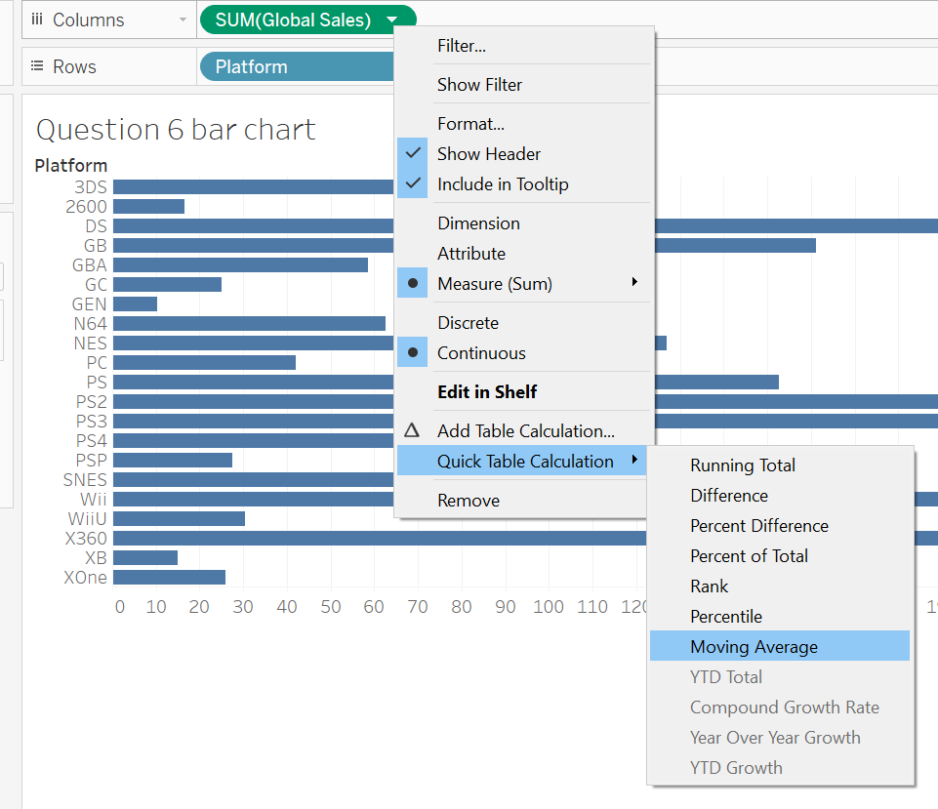

Now, let’s add another bar chart next to your existing one. Drag the Global Sales from your data tab and put it in columns next to the table calculation.

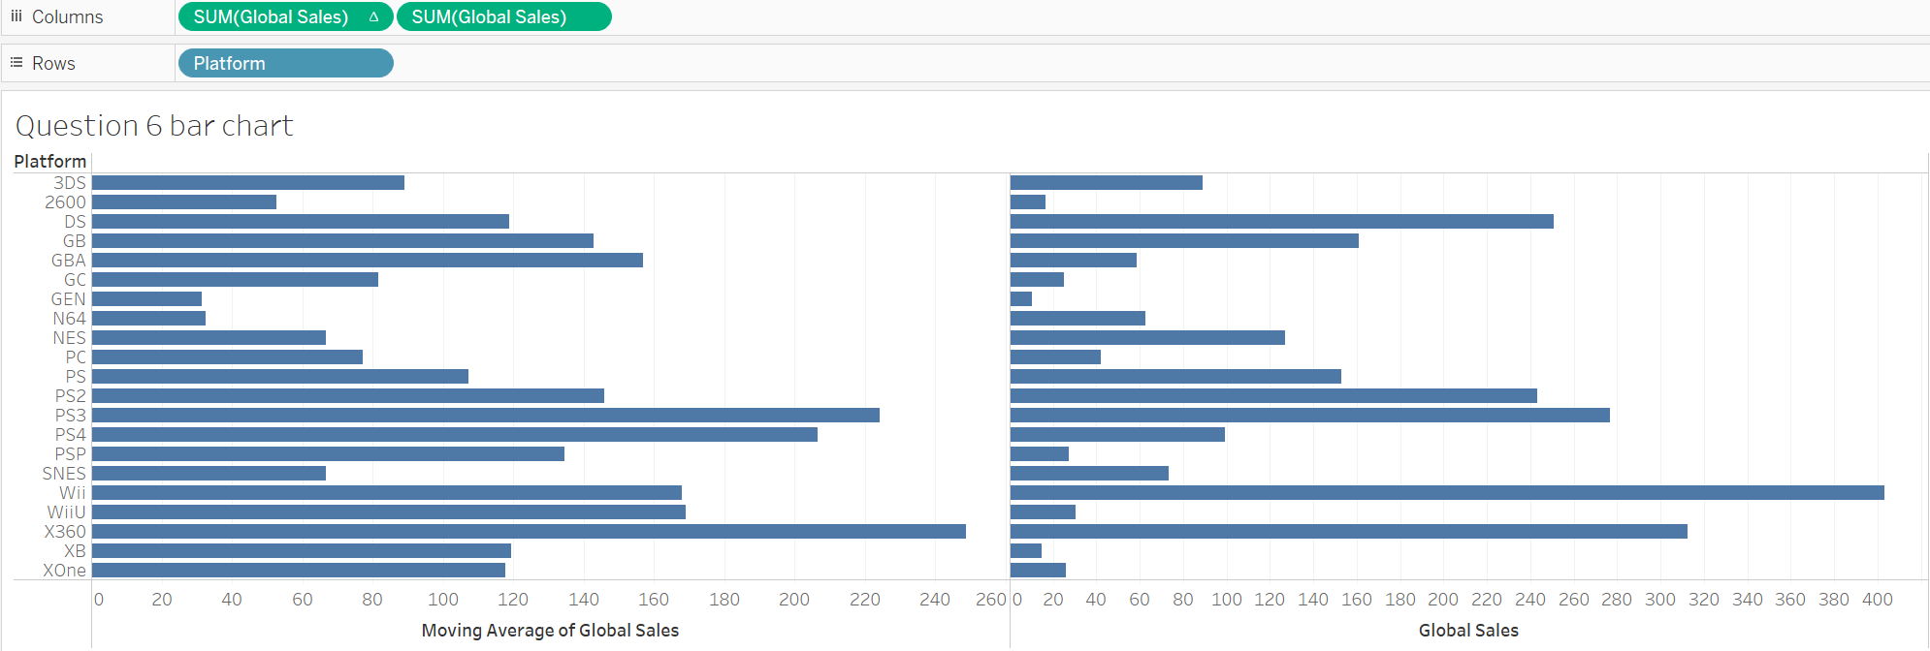

You provide this chart to a coworker, and they ask you to explain how the calculation is working here.

Why is the moving average of XB=119.3 if the global sales are only 14.9? How is the calculation working?

Option A: The calculation is totaling the global sales and dividing by the number of platforms
Option B: The calculation is totaling the current row and the two rows above it then dividing by the count of rows totaled.
Option C: The calculation is averaging the global sales by the minimum value in the set.

Question 6 Answer: | Option B: The calculation is totaling the current row and the two rows above it then dividing by the count of rows totaled.

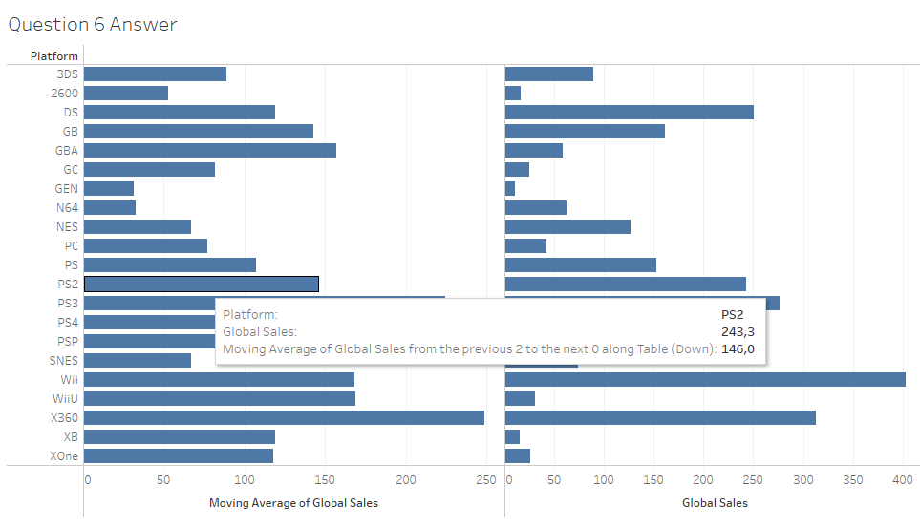

Question 7: Table Calculation Filtering

You have been asked to create an interactive visualization that allows people in your company to analyze the market share of the global sales of all years in your data set. You decide to use a table calculation (percent of total), and you want your user to be able to pick publishers so they can compare.

Drag global sales to the columns and publisher to the rows. Right-click on the SUM(Global Sales) and add a quick calculation ->Percent of Total
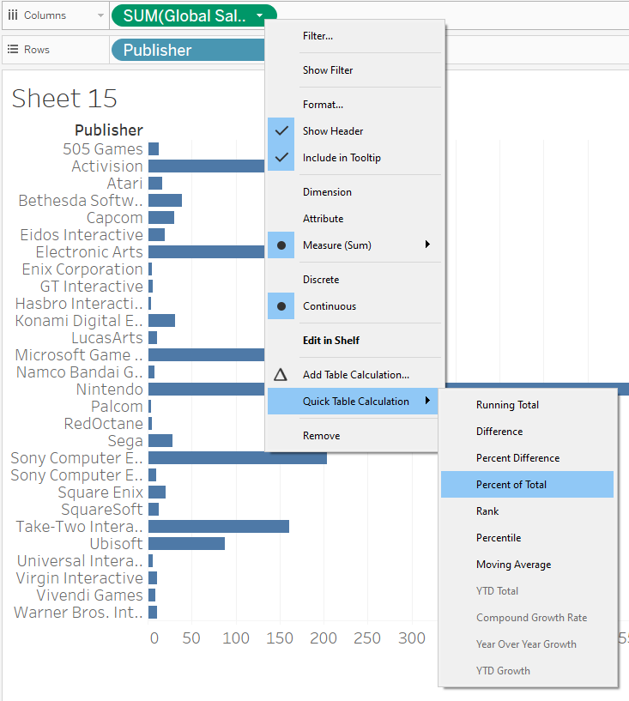

Add labels to each row, click on Label under Marks and check on “Show mark labels” and “Allow labels to overlap other marks”. 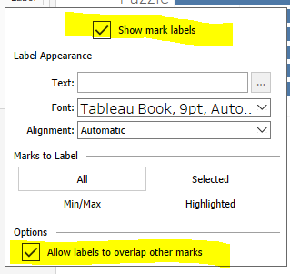

Now, we can see that Nintendo has a huge market share of 46.91%.

Let’s add the interactive part. Drag “publisher” into the filter area and click OK. Then right-click and select “show filter” to make it appear as something a user can select. 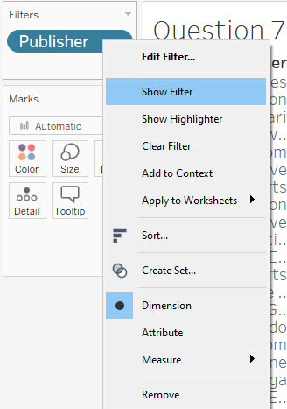

You will now see a list of publishers on the right-hand side. What happens if you uncheck the “All” button, and ONLY select two publishers? In the example below, it would appear that Activision has 89.87% of the market share and Capcom has about 10%. However, based on the bar chart earlier, Activision should be 10.66% and Capcom is around 1.2%

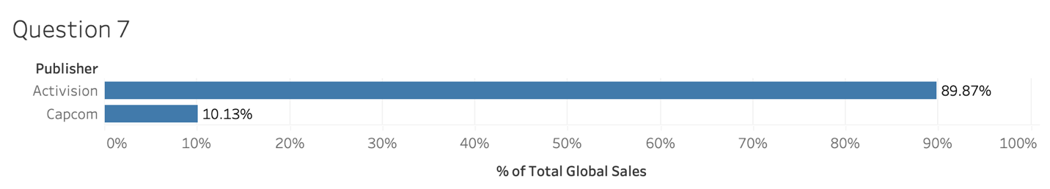

Add a calculated field that will perform a lookup called “Publisher lookup” with the syntax: LOOKUP(ATTR([Publisher]),0)
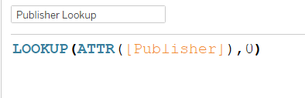

Now, drag that new calculated column into the Filters area and remove the Publisher filter. Right click to “show filter”.
Now, let’s pick the publishers Activision and Capcom. We should now see the correct percent of total calculations displaying.

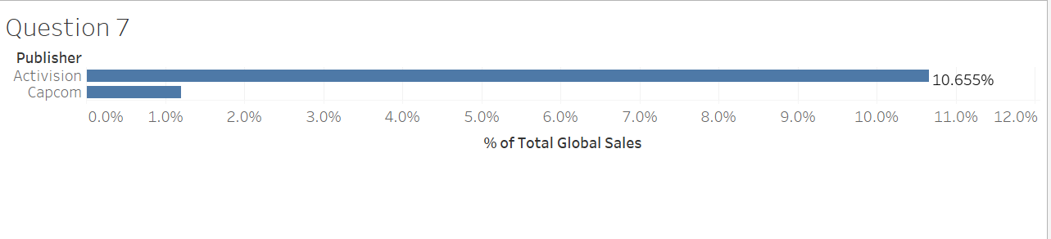
Now your coworkers really like this visualization and would like this created now for Genre.

Which of the following visualization will your coworkers see when they click on Role-Playing and Sports?

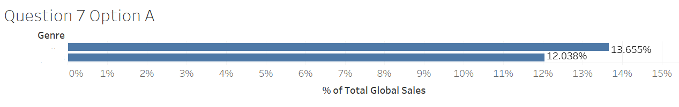 | 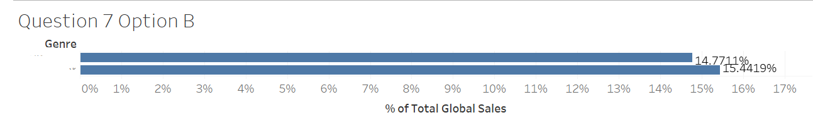
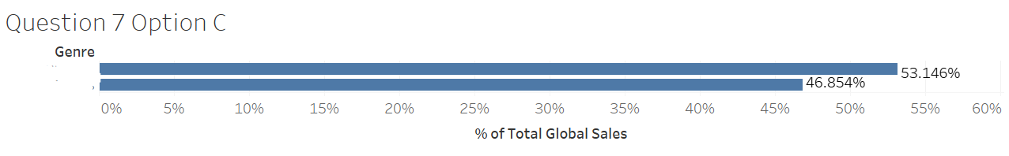 | 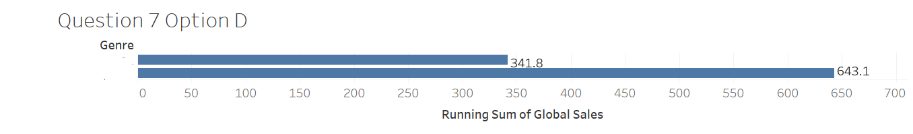

Question 7 Answer: | Option A



